
COMSATS University, Islamabad Pakistan

Students activity monitoring in online learning environments

By

Saad Bin Aziz CUI/FA17-BCS-068/ATK

Jahanzeb CUI/FA17-BCS-050/ATK

Supervisor
Dr Muhammad Shahzad Faisal

Co-Supervisor
Mr. Najam Dar

Bachelor of Science in software engineering (2017-2021)
The candidate confirms that the work submitted is their own and appropriate credit has been given where reference has been made to the work of others.
DECLARATION

We hereby declare that this application, neither whole nor as a part has been copied out from any source. It is declared that we have developed this app and accompanied report entirely based on our personal efforts. If any part of the project is proved to be copied out from any source or found to be reproduction of some other. We will stand by the consequences. No Portion of the work presented has been submitted of any application for any other degree or qualification of this or any other university or institute of learning.

Saad Bin Aziz Jahanzeb
------------------------ ------------------

CERTIFICATE OF APPROVAL

It is to certify that the final year project of BS (CS) “Student Activity Monitoring In Online Learning Environment” was developed by Saad Bin Aziz (CUI/FA17-BCS-068/ATK) and Jahanzeb (CUI/FA17-BCS-068/ATK) under the supervision of “Dr. Muhammad Shahzad Faisal” and under the co-supervision of “ Mr. Najam Dar” that in (their/his/her) opinion; it is fully adequate, in scope and quality for the degree of Bachelors of Science in Computer Sciences.

---------------------------------------
Supervisor
---------------------------------------
Co-Supervisor
---------------------------------------
External Examiner
---------------------------------------
Head of Department

(Department of Computer Science)

Executive Summary
Virtual learning or online learning became most suitable and safe learning method due to this pandemic and nearly every institution and organizations are giving their lectures online and this method is also cheaper and time saving. Now as teachers are using different platforms for teaching students like Microsoft teams, zoom and Google classroom and many more and in all of these applications teacher can’t see all of the faces of the students and in most of the cases teacher don’t ask students to turn their webcam on or students don’t so in both of the cases how the teacher will know that how many students had watched their lecture and in the case of virtual learning in which recorded lectures are given to the students and student had to watched that lectures and its difficult for the teacher to record the lecture but he does for the facility of the students but if the students don’t even watch the lectures and just read the handouts then the hard work of the teacher is just waste For this type of situation we are making an application that helps the teacher to see that how many students had watched the video lecture and how much did they watch and he can also make attendance on the percentage of the watched lecture. Our application will make a graph that will show the teacher that how much a student had watched the video lecture.

Acknowledgement
By the grace of Allah almighty; who is the most gracious and most merciful by which we are able to complete our project. We are thankful to Allah almighty who make us able to complete our task timely. All praises are for Him.
First, we would like to express profound tribute to our parents who always motivate us and never let us down morally and financially. What we are now is only due to their prayers.
“Dr. Muhammad Shahzad Faisal” is a continuous source of motivation, guidance and inspiration. He is a complete institution, our trainer; our supervisor has guided us in a way that we learn many things. We are grateful to him for making us able to achieve our goal.
We are grateful to our institution who gave us opportunity to complete our task. Some special thanks to those who are always there for boasting up, their support and their prayers who encouraged us at certain phases.
May Allah Almighty keep providing us with all the resources and the guidance to serve people. Ameen.

Saad Bin Aziz Jahanzeb
------------------------ ------------------------

- Abbreviations
- Table of contents
- List of Tables
- List of Figures
These all points will be explained later.

Chapter 1
Introduction

- Introduction:
Online or virtual learning is the learning method that is administrated through internet. Our application will be used in a very positive manner in the context of the helping the teacher to let him/her know that how much his recorded lecture is being watched.
Online education has gained immense popularity among working professionals and students pursuing higher education. These categories of online learners find immense benefit in the autonomy and flexibility that these courses offer. Online courses can be planned around their schedule which may include full-time employment, internships and caring for family. Online learning can also help them take out some quiet time to study.
Distance learning has been around for a long time, even before technology made it extremely accessible. Traditional schooling is now seeing an increased proliferation of virtual training materials and online courses. Even in a world of tried and tested schooling systems and curricula, the most successful schools are the ones who adapt to the changing times, as well as to the expectations of students, parents and the society. If online education is here to stay, then what are its implications for traditional learning? Instead of focusing on pros and cons, the conversation we should be having today is about leveraging online education to make our education systems more conducive to learning.
Online courses call for a greater amount motivation and self-discipline than a classroom-based course. A classroom has one or more instructors and peers, who can hold a student accountable for their course-work. In contrast, online courses involve setting our own goals, tracking progress and meeting deadlines. One does not learn effectively in isolation so online courses do offer discussion forums, email and one-on-one support. Technology also adds on to the visual experience by incorporating animations that can be used interactively for effective learning and communication
In our app, we have two main users Students and Teachers. Teachers will be able to see the percentage of the watched video and students will be able to log in in order to get monetarized by our application.
Every teacher will have their separate profile which includes teacher’s data such as his email, organization name, current post, contact information etc. Through graph that will be built after the video ended we will get the feedback of the students that how was the lecture .
Feedback of users helps the teacher to know that how was his lecture like may be the lecture is so boring and in same pitch of sound that students didn’t watched the lecture and he has to change his style of giving lecture.

  - Brief:
In short, the main aim of this project is to provide a platform for the teachers where they will know that their students are watching the videos lectures which they were recording with lots of hard work. It will also help them to know the feedback of the students that how was the lecture. On the user end, this app will only monetarize them and will take feedback of the lecture.
  - Relevance to Course Modules:
    - Report Writing Skills (RWS): through which we are able to write our documentation, able to know how to select format and structure to meet formal needs, ensuring that document sequence is logical, meaningful and presentable. Presenting information differently through text, graphs, tables and diagrams.
    - Artificial Intelligence (AI): is the core subject of CS regarding the development of projects using python through which we are able to learn how to code in python. This course helps us to cope up with the various issue and features of python.
    - Machine Learning (ML): is one of the main subject through which we are able to apply different techniques and algorithms to classify the data, extract required results from this classification and achieve accuracy.
    - Web Technologies (WT): is the core subject of CS regarding the development of web applications through which we are able to learn how to make websites using HTML and CSS. This course helps us to cope up with the various issue and features of web applications
    - Human computer interaction (HCI): is a multidisciplinary field of study that focuses on the design of computer and technology and especially interaction between human and computers. The design principles to improve human interaction with computer. Through this subject, we are able to make interactive and user friendly interface.

    - Software engineering (SE1 and SE2): helps us to start our final year project by 5 phases of software engineering i.e. requirement gathering, design, implementation, testing and maintenance. Different types of software models we have learn helps to decide which software model is to be used in our project according to our requirements.eg water fall, agile, spiral etc.

    - Software Design and Architecture enables us to learn the Unified Modeling Language Diagrams. How to design a software system based on requirement. This course helps in our project that how to design a system. We learn following diagram from this course.
- Activity Diagram
- Use Case Diagram
- Sequence Diagram
- Class Diagram
- Communication Diagram

    - Database Management System is one of the core course of our program that we have studied. This course helps in interacting with the relational databases that are used by most of the applications now a days. It helps in understanding queries, joins, constraints, validations, stored procedures, function etc. These all are the techniques that we have used in this project.

  - Motivation and Scope:
Education has the most important effects on society that is giving the people who live in a society the skills they need to compete in the global marketplace, and the skills they need to produce technological goods that can be sold on the open market. Usually teachers are just giving their lectures online and providing students recorded lectures in hybrid courses without knowing student had watched the lecture or not and in most of the cases a teacher is just wasting his hard work because some of the students watch the lecture and understand it and at the time of papers or evaluation they just teach others then why the teacher is making the recorded lecture for the whole class he will send the lecture to only specific students and why he is marking the attendance of all students in order to handle this situation we are making this application
Instead of marking the attendance of the students on the basis of quiz and assignments the teacher will mark attendance of every class like he or she does in physical mode of learning and also he or she don’t have to do anything attendance will be marked present if the student had watched the video lecture at least 80%.
  - Literature review:
Education is the act or process of imparting or acquiring general knowledge, developing the powers of reasoning and judgment, and generally of preparing oneself or others intellectually for mature life. the act or process of imparting or acquiring particular knowledge or skills, as for a profession. As it is era of technology and almost everything is being held online and education is also converted to online mode and this is so much effective in every aspect like cost and time so we are trying to make this mode of learning more efficient that the imprudence of the students will not be there and everyone will forcefully focus on the lectures and the thing is if students knows that he had to watched to lecture then he will listen it and will don’t even cheat in evaluation because he will know about the lectures and will

solve the exam by his or herself . No such type of any app is designed and developed yet in Pakistan.
  - Analysis from Literature Review:
Table 1: Analysis of literature
Application Name | Features | Weakness
Online Student Attendance System in PHP Mysql | Store student daily attendance record and make PDF report from attendance data. | These all apps are just maintain and manage the attendance of student by only face detection and making use of face recognition technique.
Online attendance management system. | innovative tool to maintain and manage the attendance of students/employees.
Online Student Management System in PHP | the user can view announcements, recent posts, and departments. From the instructor account, the user can view the student’s list and take actions on their grades by adding on each.
Smart attendance management system using face recognition | Used to detect faces in images and deep learning method is used to compute and compare feature facial of student to recognize them
Face Detection and Recognition Student Attendance System | face detection and recognition in image processing to build a system that will detect and recognize frontal faces of students in a classroom.
Real-Time Smart Attendance System using Face Recognition Techniques | automated attendance management system for students of a class by making use of face recognition technique

    - Features of our App:
- Student Activity monitoring of online lectures
- Summarize the student’s history of watched lecture
- Student gives the feedback to the teacher
- Teacher can modify his lecture according to the feedback
- Teacher can mark attendance of students according to summary generated by our app
  - Methodology and life-cycle:
Methodology selection is as important as first building block for development of application. After designing of this app, the methodology selected should be flexible so that it can be molded as user’s interest changes or with any increase in features of application. For example introducing new fields and features. So, our project will follow agile process model.
    - Rational behind selected Methodology
We selected agile development as the possibilities of changes in system are high as user’s interest and priorities may change or may be new features will introduced. This development focuses on user’s satisfaction. In this case teacher are the main users who have to motivate the student to watch the whole lecture and learn and understand from the recorded lecture. So the main objective of this app is to provide an integrated communication platform where they will satisfy the teacher and student.

Chapter 2
Problem Definition

- Problem Definition

  - Problem Statement
Problems are just like uninvited guests; but only solution is to face or searching for better solution. Technology is advancing day by day but there is a gap between student interest and the adoption of the right field. Educational issues impact essentially every part of our lives.
In online learning environment the main problem arises it the students don’t watch the video lectures and just give their exams through cheating and this just wastes the hard work of the teacher who had made recorded lectures for them in the whole course and the thing is when the student is being bound on watching the lectures the lecture then he will definitely learn from that lecture and will not do the cheating in the exam and teachers will not go blindly that students had watched the lecture .

  - Deliverable s and Development Requirements:
Our project delivers only on one platform i.e. Web Application. Our app will help the teachers to know that how many students had watched the lecture and also how much they had watched
At the end of 8th semester, we will present the following outputs:
- Dataset
- Web App.
- Documentation

    - Tools:
- Firebase database
- MS Word
- MS PowerPoint
- Pycharm
- Visio 2016
- Jupyter notebook
- Vs code

    - Languages:
- Python
- C#
- Html / css

Chapter 3
Requirement Specification

- Requirement Specification:
In this part, we will talk about necessities of the task. In the sub areas, we will examine useful, non-useful requirements and use-instance of project. Prerequisite elicitation and examination is one of the significant piece of project development lifecycle. Software requirement specification characterizes the prerequisite that will be planned and afterward will be created to make a working item.

  - Use case Diagram[s].
Following are the use case diagrams of this project:

    - Teacher and student Use case:

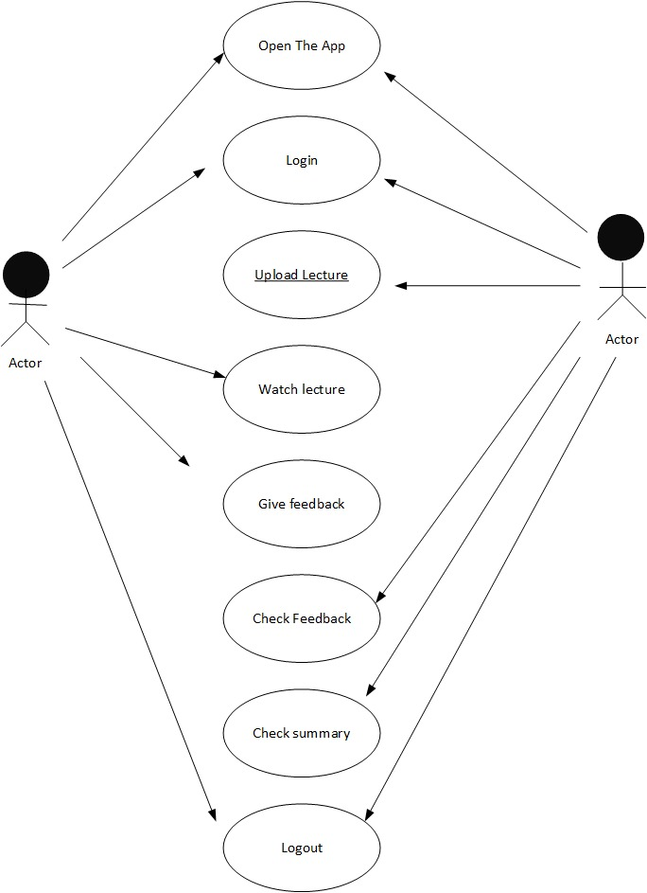

  - Detailed use case:

    - Student use case:

      - Sign-up for student
Table 01: Sign-up
Use case name | Sign Up for student
Actor | Student
Description | Student can register their profile in the system.
Pre-condition | Student must not be registered.
Post-condition | Student’s data will be added to database and redirect to login page.

      - Login for student:
Table 02: Login
Use case name | Login for student
Actor | Student
Description | Student can login to the system to perform related activities
Pre-condition | Student’s data already in the database.
Post-condition | Connection to server establishes, and candidate logged in successfully.

      - Complete the Profile:
Table 03: Complete the profile
Use case name | Complete the profile
Actor | Student
Description | Student can answer to the questions provided on the form to provide the necessary information about him.
Pre-condition | Student must be logged into the system.
Post-condition | The rating of the answers of the questions will be given to the server

      - Upload picture:
Table 04: Upload picture
Use case name | Upload picture
Actor | Student
Description | Student can upload any picture or video related to his campaign or any political stuff.
Pre-condition | Student must be logged into the system and camera or gallery must be accessible
Post-condition | Uploaded item will be saved in database and will be displayed on his profile to show to the users.

      - Camera permission :
Table 05: camera permission
Use case name | Camera permission
Actor | Student
Description | Student can upload any picture or video related to his campaign or any political stuff.
Pre-condition | Student must be logged into the system and camera or gallery must be accessible
Post-condition | Uploaded item will be saved in database and will be displayed on his profile to show to the users.

      - Watching videos lectures :
Table 06: watching videos lectures
Use case name | Watching videos lectures
Actor | Student
Description | Student can upload any picture or video related to his campaign or any political stuff.
Pre-condition | Student must be logged into the system and camera or gallery must be accessible
Post-condition | Uploaded item will be saved in database and will be displayed on his profile to show to the users.

      - Give a Feedback:
Table 7: Give a feedback
Use case name | Give a feedback
Actor | Student
Description | Student can give a comment on the lecture uploaded by a teacher. Student’s comment can be positive or negative depends on whether he like that lecture or not.
Pre-condition | User must be logged in.
Post-condition | That comment is stored in database for further processing such as classifiers will classify them to negative or positive and it help in marking the reputation of teacher.

      - Logout for Student:

Table 8: Logout for student
Use case name | Logout
Actor | Student
Description | Student can logout from the system to secure its data
Pre-condition | Student must be logged in.
Post-condition | Student will navigate to the start page of app which shows that he logged out successfully.

    - Teacher use case:
      - Sign-up for teacher
Table 9: Sign-up for teacher
Use case name | Sign Up for teachers
Actor | Teachers
Description | Teacher can register their profile in the system.
Pre-condition | Teacher must not be registered.
Post-condition | Teacher ’s data will be added to database and redirect to login page.

      - Login for Teachers:
Table 10: Login for teacher
Use case name | Login for Teachers
Actor | Teacher
Description | Teacher can login to the system to perform related activities
Pre-condition | Teacher’s data already in the database.
Post-condition | Connection to server establishes, and user logged in successfully.

      - Complete the Profile:
Table 11: Complete the profile
Use case name | Complete the profile
Actor | teacher
Description | Teacher can answer to the questions provided on the form to provide the necessary information about him.
Pre-condition | Teacher must be logged into the system.
Post-condition | The rating of the answers of the questions will be given to the server

      - Upload video lecture:
Table 12: Upload video lecture
Use case name | Upload video lecture
Actor | teacher
Description | teacher can upload lecture video related to his subject or can post any other video related to that topic.
Pre-condition | teacher must be logged into the system and camera or gallery must be accessible
Post-condition | Uploaded item will be saved in database and will be displayed to the students

      - Search student:
Table 13: search student
Use case name | Search student
Actor | teacher
Description | teacher can upload lecture video related to his subject or can post any other video related to that topic.
Pre-condition | teacher must be logged into the system and camera or gallery must be accessible
Post-condition | Uploaded item will be saved in database and will be displayed to the students

      - Check Feedback:
Table 14: check feedback
Use case name | Check feedback
Actor | teacher
Description | Student can give a comment on the lecture uploaded by a teacher. Student’s comment can be positive or negative depends on whether he like that lecture or not.
Pre-condition | User must be logged in.
Post-condition | That comment is stored in database for further processing such as classifiers will classify them to negative or positive and it help in marking the reputation of student.

      - Check summery:
Table 15: check summery
Use case name | Check summery
Actor | teacher
Description | Teacher will check the summary that which student had watched how much lecture
Pre-condition | User must be logged in.
Post-condition | Teacher will be able know report of every student and can mark attendance on the basis if that summary

      - Logout for teacher :

Table 16: Logout for teacher
Use case name | Logout
Actor | teacher
Description | Teacher can logout from the system to secure its data
Pre-condition | Teacher must be logged in.
Post-condition | Teacher will navigate to the start page of app which shows that he logged out successfully.

  - Functional Requirements
Functional requirements are those functions that a system must do in order to achieve specific goal in specific situation. Functional requirements include a specific task, technical details, calculations, logic, processing, and data manipulation of a system.
    - Sign-up for student/teacher
Table 17: FR-1 sign-up
Name | FR-01: sign-up for student/teacher
Function | Register/Sign Up student and teacher into the system
Priority | Required for the first time (High)
Requirements | To add new users to the system, all users must be enrolled in the system before enrolling in the class.

    - Login for Student/ Teacher
Table 18: FR-2 login
Name | FR-02 : sign-up for student/teacher
Function | login student and teacher into the system
Priority | Required for every class(High)
Requirements | The student and teacher shall be able to login to the system by entering the valid email address and password. The homepage requires having a login mechanism in order to identify unique person and maintain session.

    - Upload lecture and videos :
Table 20: FR-3 upload lecture and video
Name | FR-3: upload lecture and videos
Function | Teacher will upload video lecture and post anything related to course and topic.
Priority | Required for every class (High)
Requirements | For uploading videos lecture application must be connected to database.

    - Camera accessibility and eye ball detection :

Table 21: FR-4 camera accessibility and eye ball detection
Name | FR-04 : camera accessibility and eye ball detection
Function | Student will give permission to application to start the camera and detect the eye ball of student during the video lecture
Priority | Required for every class (High)
Requirements | Camera must be installed and in working condition and the student focus must be towards the video lecture.

    - Generate the summery of video lecture:
Table 22: FR-5 generate the summery of video lecture
Name | FR-5 Generate the summery of video lecture
Function | This application will generate a summery of watched video lecture and give a output to teacher.
Priority | Required for every video lecture (High)
Requirements | Student must attempt the video lecture and must on the camera

  - Non-functional Requirements:
Non-functional requirements are those requirements that participate with functional requirements to help and define the system quality with respect to the following parameter from NFR-01 to NFR- 5.
    - NFR-01 user interface:
NFR-01-1 | - User Interface should be clean and compatible with laptop.
NFR-01-2 | - User Interface should be simple so the teacher and student can easily understand it.
    - NFR-02 usability of application
NFR-02-1 | - The user interface of the app shall be responsive.
NFR-02-2 | - Easy use as chances of error will be minimum and the user can navigate through the app easily.

    - NFR-03 Devices:
NR-03-1:  RAM | The device should have at least 4 GB RAM
NR-03-2:  Camera | The device should have a better camera to detect the face of student and eye ball .

    - NFR-04 Performance:
NFR-04-1 | - The user interface of the app shall be responsive.
NFR-04-2 | - Easy to use as chances of error will be minimum and the user can navigate through the app easily.

    - NFR-05 Security:
NFR-05-1 | A student will not be able to access the account of any other student or teacher

Chapter 04
Design and Architecture:

- Design and Architecture:
  - System Architecture:
    - Flow chart
Flowchart for teacher :-

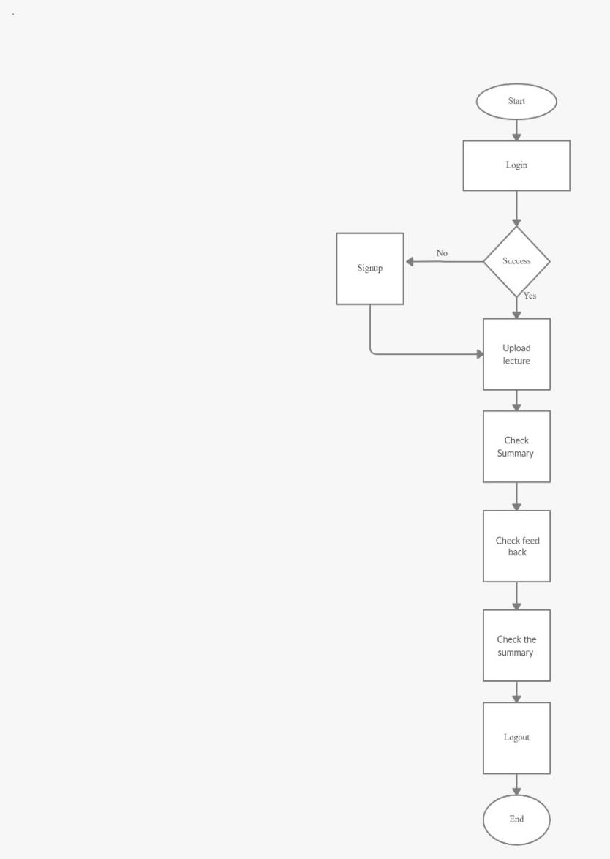

Flowchart for student:-
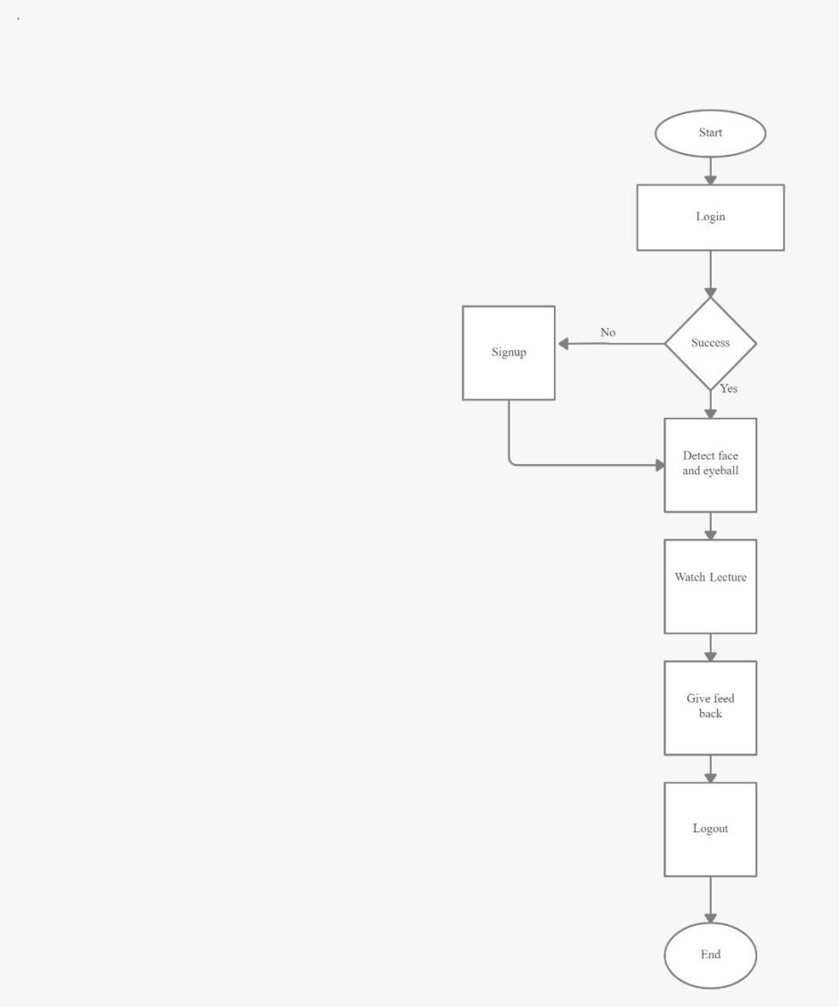

  - Project Design
In this chapter we discuss about the methodology, tools, programming language, and game architecture used to develop our project.
  - Methodology
Methodology selection is as important as first building block for development of application. After designing of this app, the methodology selected should be flexible so that it can be molded as user’s interest changes or with any increase in features of application. For example introducing new fields and features. So, our project will follow agile process model.

  - Programming Language
- C#
- Python
  - Development Tools
- Vscode
- PyCharm

  - System Architecture
Here’s the final system architecture for our project for student
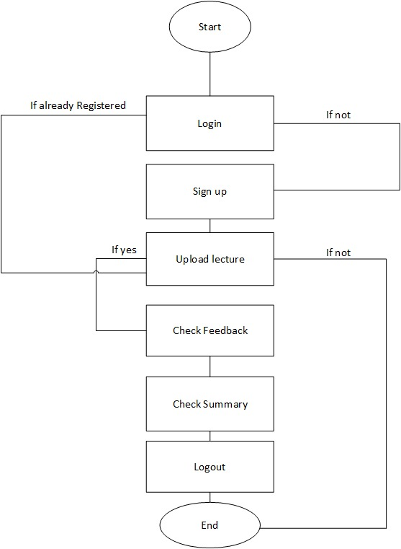
Here’s the final system architecture for our project for teacher.
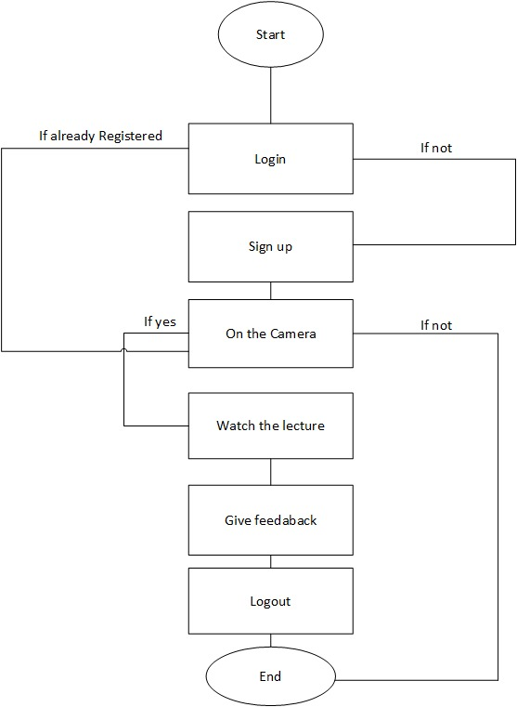
  - Design Description
The product configures the models described below. For the sake of simplicity, readability and comprehension, we only mention the important features and processes of each module.
    - Data Flow Diagram
In this section, we draw Data Flow Diagrams known as DFD to illustrate different stages.
      - DFD Level 0
DFD Level 0 shows how the student accesses the application and thus how he/she use application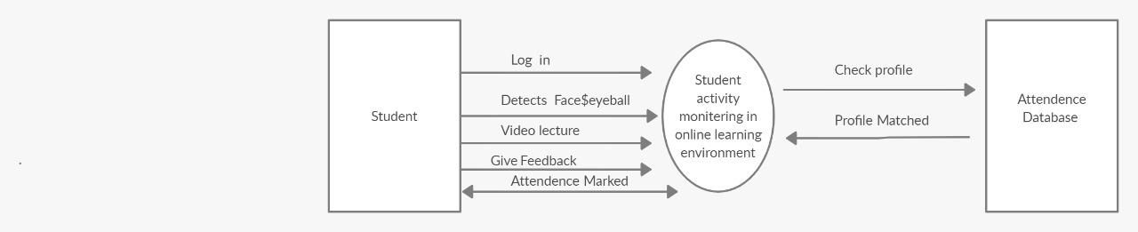
      - DFD Level 1
This DFD shows gives more clarity as compared to the previous one.
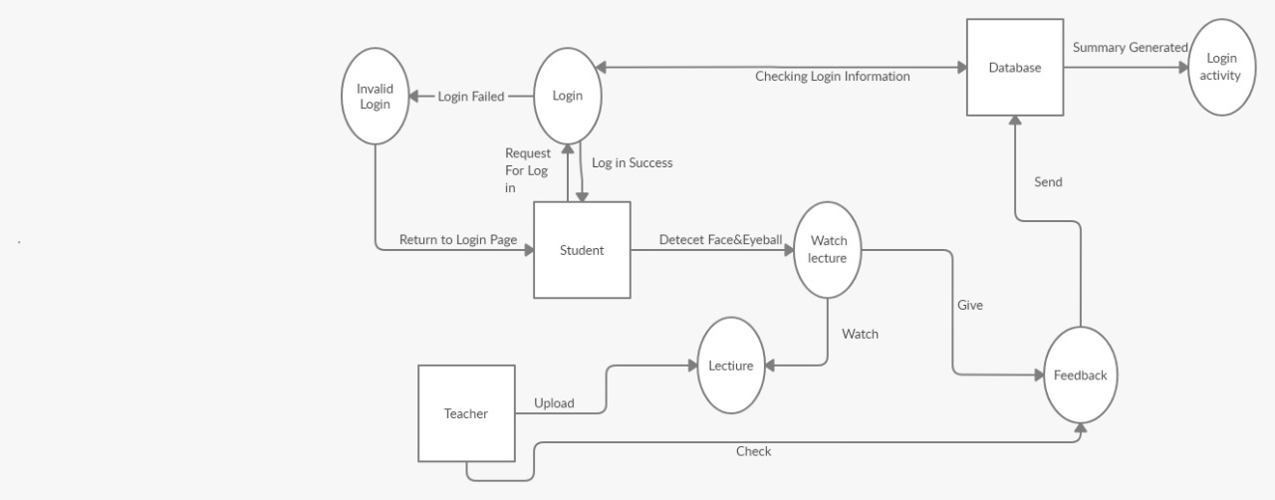
    - Sequence Diagram
Students click on the application to launch it, and after a few seconds the screen loads. After Some seconds, menu loads and the interface is displayed to students and teachers.
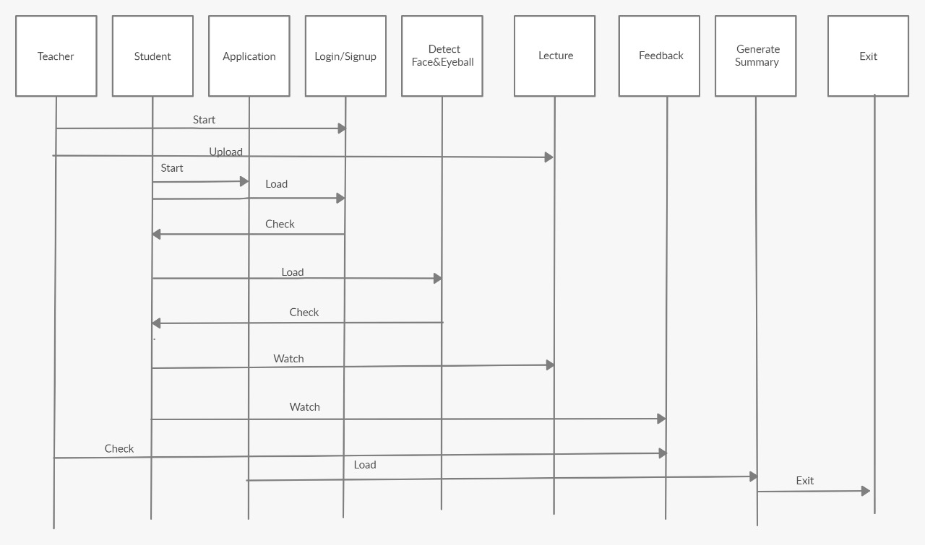
    - Activity Diagram
Activity diagrams (such as flowcharts and data flow diagrams) visually represent a set of actions or control flows in the system. Single black dot represents the initial node/starting point and at the end black dot in the circle represent final node. Arrows is basically work as connector. And the black line represents a fork node means divide a single incoming flow into multiple flows.
